SHANKAR M

Environment Setup

IBM Cloud Account Creation

|  |  |
| --- | --- |
| Team ID | PNT2022TMID02819 |
| Project Name | Nutrition Assistant Application |

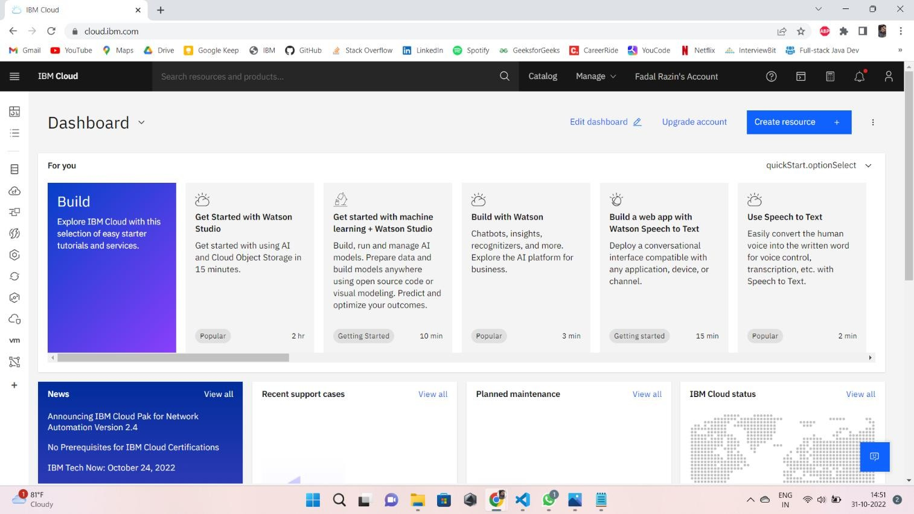

SRINATH K

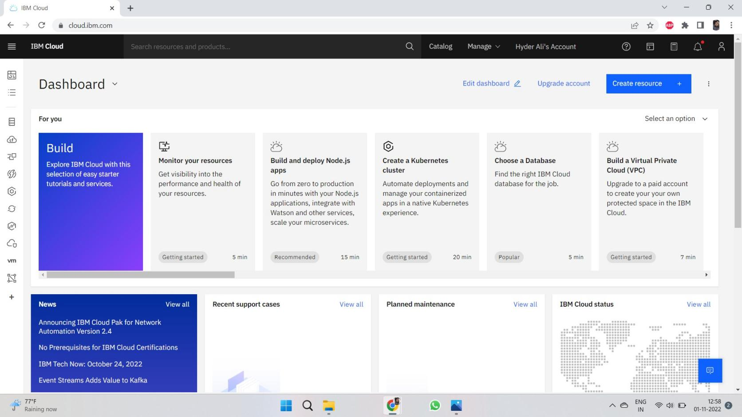

SHIYAMABISHAK N V

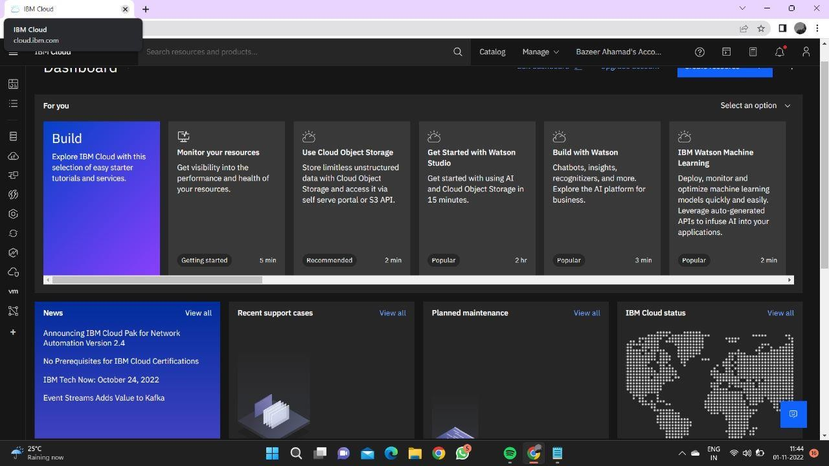

SHARAN PRASAD S

